**Apache Web Server Installation**

1. Login as sudo privileges and set Java_Home.
2. First step is to use dnf command to [install package](https://linuxconfig.org/how-to-install-packages-on-redhat-8) called httpd: dnf install httpd

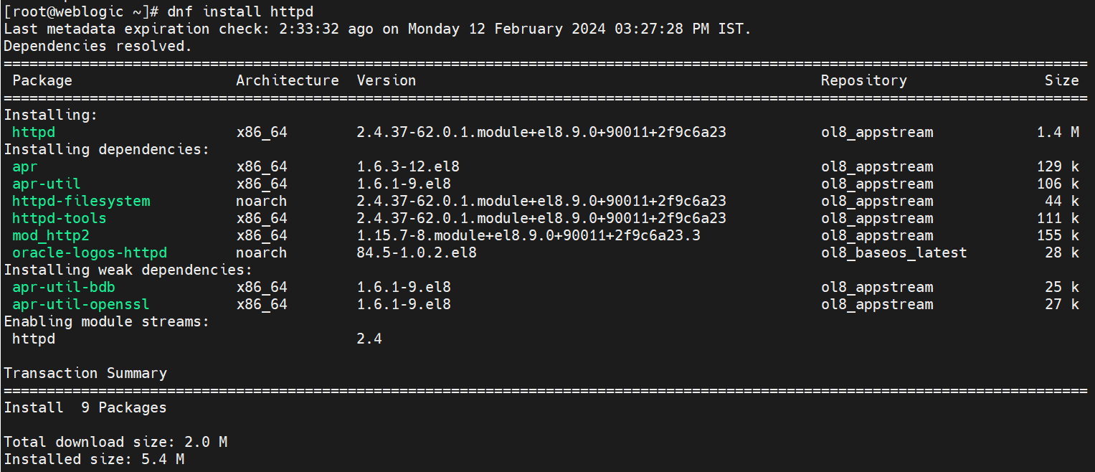

1. Run and enable the Apache webserver to start after reboot:
2. systemctl enable httpd
3. systemctl start httpd



1. Optionally, if you need your Apache web server to be accessed from remote locations open HTTP firewall port 80:
2. firewall-cmd --zone=public --permanent --add-service=http
3. firewall-cmd --zone=public --permanent --add-service=https
4. firewall-cmd –reload

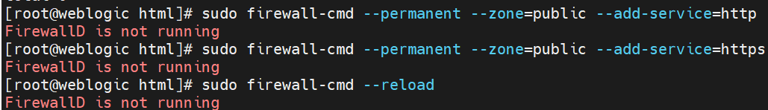

1. Verify the Apache Installation:

Command: sudo systemctl status httpd

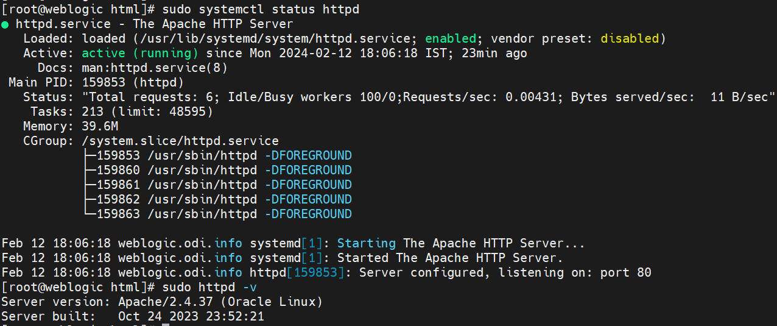

1. To check Os Server version

Command: sudo httpd -v

1. Insert your website files.

* By default the Apache web server will greet you with a default welcome page.
* To disable the default Apache welcome page insert
* your index.html into /var/www/html/ directory. For example:

echo Apache on RHEL 8 / CentOS 8 > /var/www/html/index.html

1. To access your new sample website navigate your web browser to either http://YOUR-APACHE-IP-ADDRESS or http://YOUR-APACHE-HOSTNAME.

Example: http://192.168.1.45

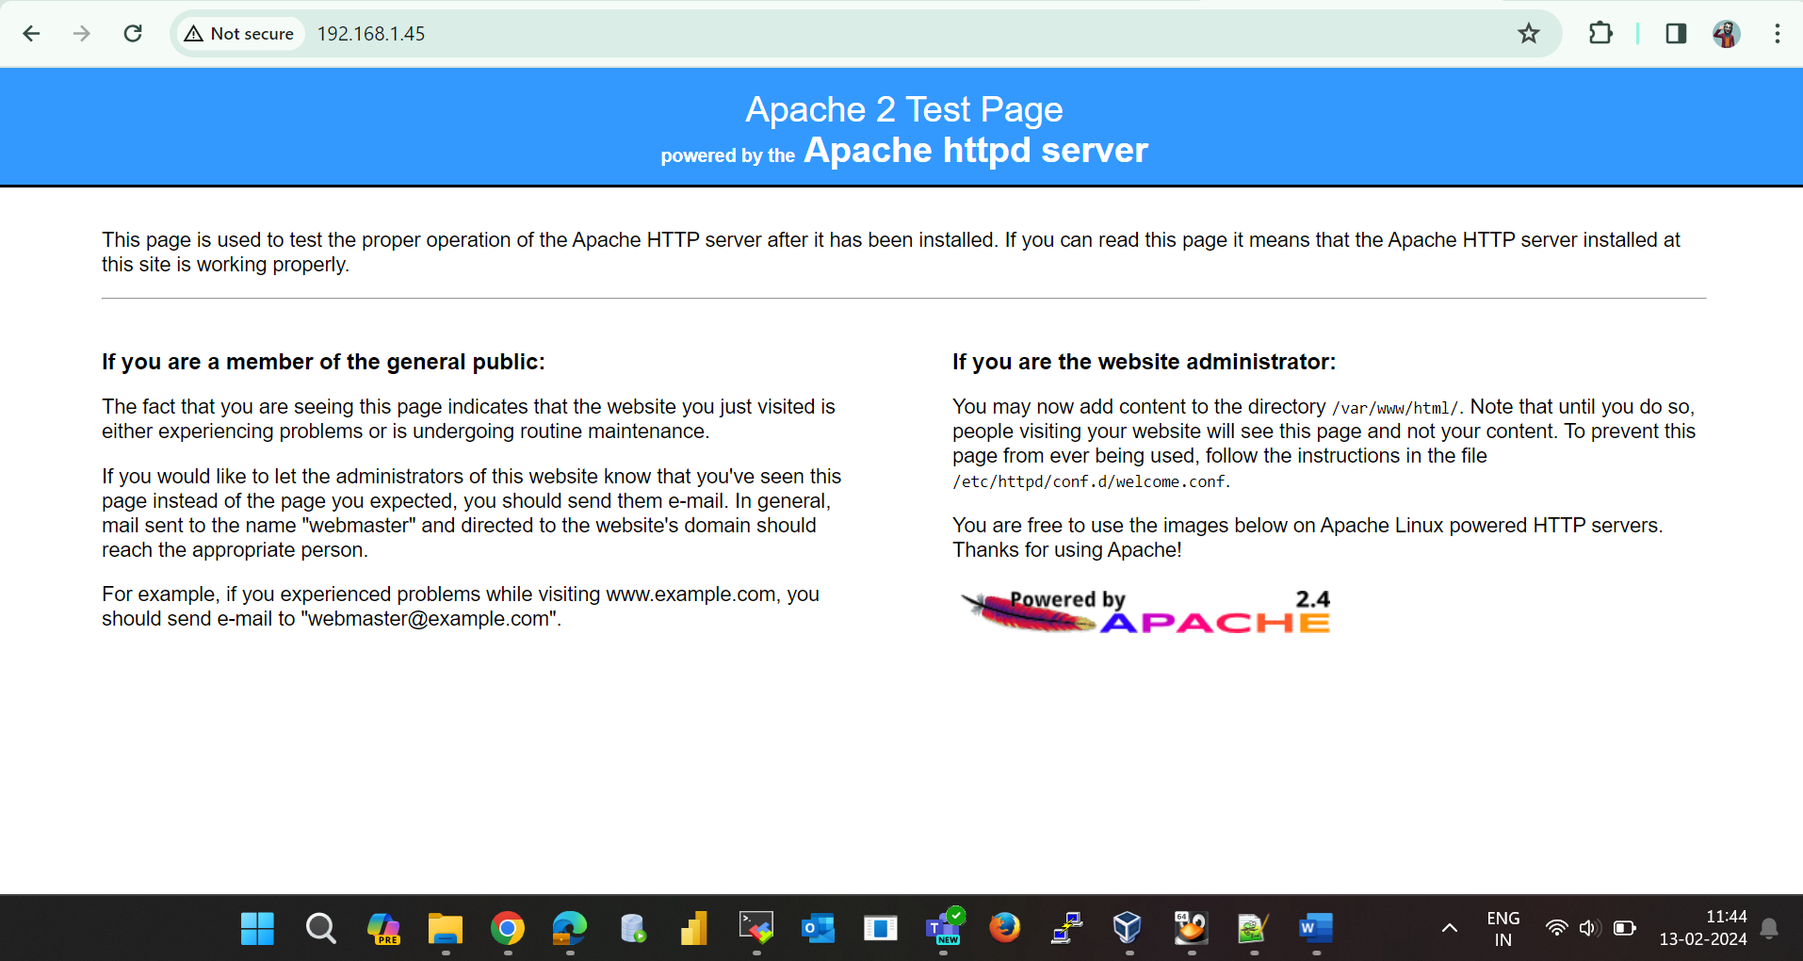

**Manage the Apache Services:**

* To stop httpd service use following command: **sudo systemctl stop httpd**
* To start again httpd service, run following command: **sudo systemctl start httpd**
* To restart apache httpd service, use the following command: **sudo systemctl restart httpd**
* To reload apache httpd web service after any changes, run following command: **sudo systemctl reload httpd**
* To disable apache httpd service to start on boot, use following command: **sudo systemctl disable httpd**
* To enable httpd service again, use below command: **sudo systemctl enable httpd**

**Apache Configuration File’s Structure:**

* The Apache2 configuration file’s default location is **“/etc/httpd/”** directory.

* The main Apache2 web server configuration file is **“/etc/httpd/conf/httpd.conf”.**

* The virtual host files configured on Apache webserver stored in the **“/etc/httpd/conf.d/”** directory. The configuration file ending with “.conf”.

* The apache web server’s module configuration files stored in the **“/etc/httpd/conf.modules.d/”** directory.

Generally  we can configure all virtual host in a single file, but I suggest to create seperate vhost files.

To troubleshoot or debug the issue with the apache web server, use the log file for apache server and virtual host. The log file for apache located at **“/var/log/httpd/access.log”** and **“/var/log/httpd/error.log”**. To make it easy to troubleshoot an issue with different virtual host need to create different access and error log for each virtual host.

There is no location boundary to create document root directory, you can create at any location but as per suggestion, the most common location for webroot directory is:

* /var/www/<site_Name>
* /var/www/html/<Site_Name>
* /opt/<site_Name>
* /home/<user_name>/<Site_Name>